CARES ACT PRF FOR ECW USERS
By S. Ramchandra, Bay Colony Pediatrics 6/25/2020
Two important numbers you need for Cares Act PRF Funds can be generated by ECW. Lost revenues (Field 13) and % distribution by Insurance (Fields 17 to 24). This is the method I used to extract data from ECW Ver 11, .exe version. I don’t use the cloud version (11e). You must have some basic skills in MS Excel for Fields 17 to 24. A high school student who has used Excel can do it.
- Field 13 Lost revenues due to COVID-19: The CARES PRF Application is not too particular on how accurately you calculate it. Even an estimate is good. “You may use any reasonable method of estimating the revenue during March and April 2020 compared to the same period had COVID-19 not appeared.” You have to compare it with 2019 (not 2018 or 2017). MAKE SURE YOU REPORT THE $ AS A NEGATIVE (Put – sign) NUMBER IN FIELD 13.
  - Method A: One can take 2019 annual income from patient related encounters and divided it by 6 for 2 month average income. Then compare it to March and April 2020 posted income from patient encounters. The difference is the lost revenues for Field 13.
  - Method B: If you have not posted March and April EOPs, here’s one way to do it. The basic approach is
Calculate average $ per Billable Visit for 2019: $ per billable visit = 2019 Annual Patient Related Income divided by 2019 Number of Patient Billable Encounters.
Losses = $ per visit x (2020 Mar thru April No. of Billable Visits - 2019 Mar thru April Billable Visits). If negative, it’s a loss.
Calculating 2019 Number of Patient Billable Encounters: See ECW screenshots.
Step 1: On the left panel go to Registry>Lookup Encounters
Step 2: In the Lookup Encounters screen, 1) Pick All Providers from Dropdown Arrow and change service dates to whole of 2019 for $/visit calculations as shown or Mar April 2019 or 2020 as needed for loss calculation. 2) Pick CHK (checked out) for Visit Status and Visit Types ALL. All our checked out visits are billable. 3) Uncheck box ‘Show Unique Patients’ and Hit ‘Lookup’ to run the report.
Step 3: Read the number of encounters at the bottom left of the screen called ‘records’

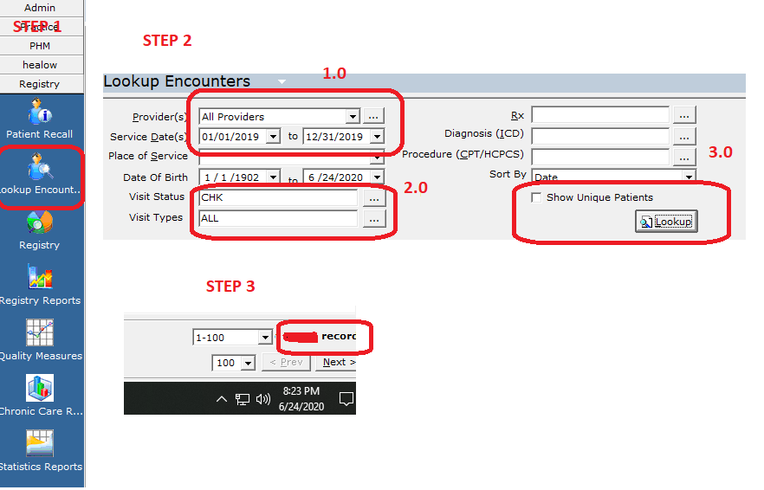

Divide the 2019 Annual Income by No. of Encounters from Step 3 above. Make sure you add all bonuses, capitation etc. This gives you $ per visit. With this method, you don’t have to worry about well visits, sick visits, shot visits etc. Say you got $100/visit.

For calculating visits in Mar through April 2019 and 2020, just change the Service date ranges in step 2 above, keeping everything else the same. Hit Lookup to run fresh data. Read Visits in step 3. Say 2019 Mar Apr was 1000 visits, and 2020 was 500 visits. Loss = $100/visit x (500-1000) = -$50,000.
- Field 17 to 24: Percent Revenues by Insurances. Field 17 says Medicare. You should have 0%. If you see Medicare patients, you would have got funds and you are ineligible for this round of Medicaid relief funds.
This report is run using EBO canned reports. I believe every ECW user gets the canned report version of EBO. See screen shots.
Step 1: Open EBO. Go tabs on the top Reports> EBO Reports
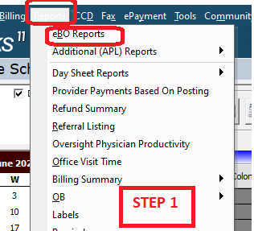
Step 2: When EBO opens, go to Report Number 36.14 Financial Analysis At Claim Level
Step 3: In Report Number 36.14 Financial Analysis At Claim Level change options as follows.
A) Date range must be Custom Date. DATE RANGE MUST BE SAME AS IN FIELD 10, AND FIELD 11. For example, if you are uploading 2018 tax return, run report from Jan 01 2018 to Dec 31 2018.
B) Pick Service date (not Claim date) and Unassociated in the dropdowns.
C) Group Reports by Insurance (If you have setup Insurance Groups and you know it’s correct, use that)
D) Deselect all options for display and ONLY pick Self Pay Charges (we collect almost all self-pay before we see the patient) & Insurance payments. Patient payments include copays so don’t pick this.
E) Hit OK to run report. Run report off hours as EBO can slow down ECW.
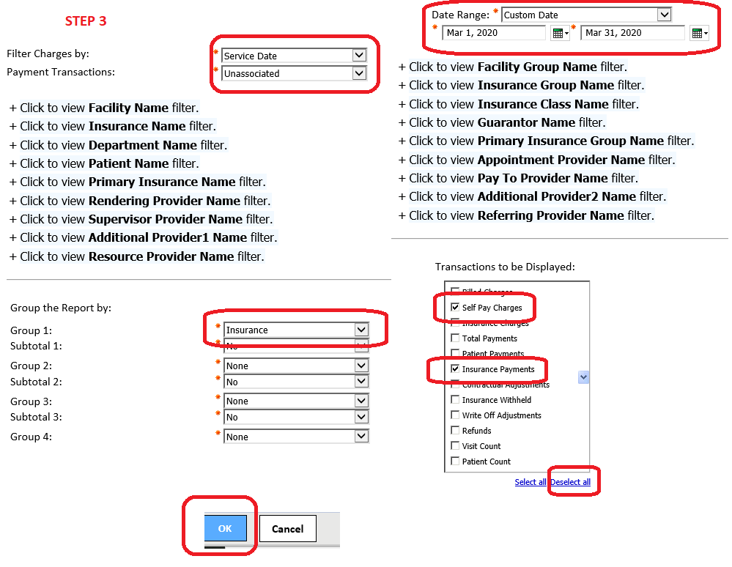

Step 4: After the report runs, go to right corner and follow steps to get report in Excel format. I pull reports in Excel 2007 data format. After Excel is run download report as “save as” a workbook not HTML.
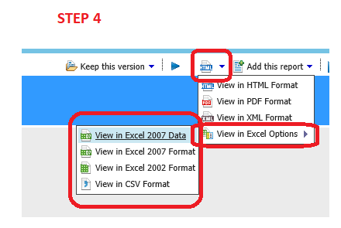
Step 5: Open the Excel Report.
A) Add a new column (highlight Column C, right click, pick ‘Insert’) and call it Type
B) Fill in labels in column Type for each payer in the rows: P = Private; M=Medicaid; S= Self pay; OG= Other Govt.; O=Other. If you get capitation payments, P4P payments etc. add it in the rows and call it P or M depending who paid you. We do not enter these values during posting because they are not tied to encounters. Tricare is other Government payments per Optum.
C) At the bottom, I have created new rows with Medicare, Medicaid, Private, Self Pay etc.
D) Select the whole worksheet from to left corner and go to “data” and select “Filter”
E) Filter Type for example M (Medicaid) and add rows to get total and enter under Total Dollars for MEDICAID and so on. I often copy the filtered data and “Paste Special”> “Values” only in another worksheet to avoid errors.
F) Calculate % under Percent Column. Report % without any decimal places, in Fields 17 to 24. It must add up to 100.

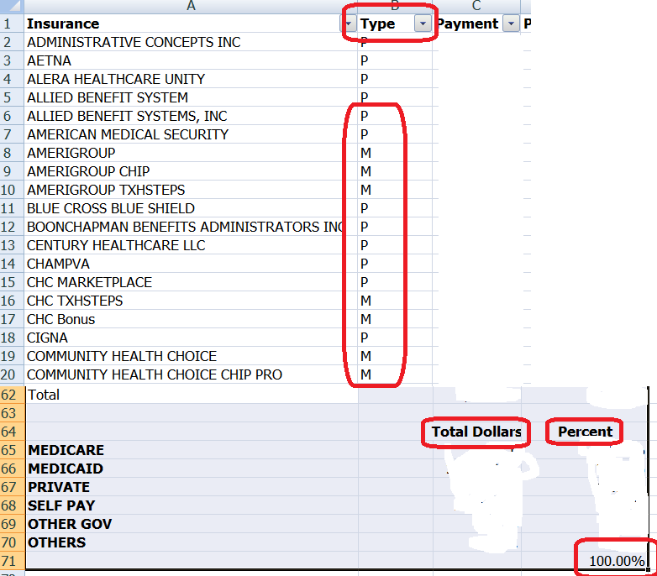
PS: There are other ways to do this. We have insurance groups setup in ECW and it directly gives us the data. With the full EBO version, one can create custom reports to generate losses posted. But the above methods give accurate enough data.

